Equipment | Materials Science and Nanotechnology
Autolab/PGSTAT302N Potentiostat, Netherlands: Link | Plasma enhanced CVD (PH300DSV), Photon, Egypt: Link
DC sputtering (PH100RPV), Photon, Egypt: Link | Zetasizer Nano ZS90, Malvern, UK-Link
 | 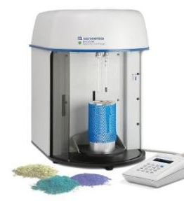
Solar Simulation (94021A), Oriel inst., USA: Link | BET-Surface area analyzer  Gemini VII 2390 Analyzers, Micromeritics, USA: Link
Metallurgical Microscope (NJF-120A), China (Mainland) | LCR Meter (Hioki 3532-50), HIOKI, USA: Link
Ultrasonic Processor (VCX 500), Hainertec, USA: Link | UV-VIS spectrophotometer (T80), PG inst. Lim., UK: Link
Microwave Reaction System:  Multiwave PRO, Anton Paar, Austria:  Link | Electrospinning, hand-made
Cooling Centrifuge (MPW-260R), MPW Med. Inst., Poland: Link | Centrifuge (PLC-036), Gemmy Co., Taiwan: Link
Muffle Furnace (DMF-12), DAIHAN Scientific, Korea: Link | Ball mill, Photon, Egypt: Link
Dryer (WOF-155), Daihan Scientific, Korea: Link | Tube furnace (TF-80), Lab house, Korea: Link
Hydraulic Jack, China | Hot press (YLT-HP88V), MTI Corporation, CA: Link

